Water Heater Ntc Thermistor Temperature Sensor Probe
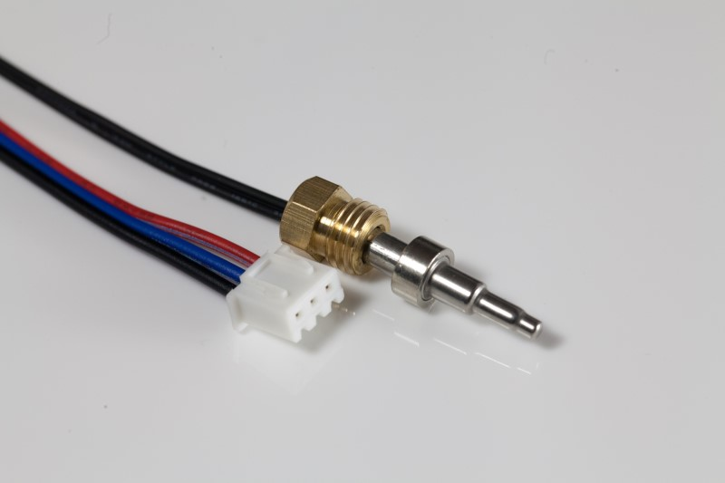
MFP series temperature sensor using the NTC resistance element, according to the different temperature environment or application, through the mature technology, fabricate into a variety of specifications of the sensor, customers can use directly without fabricating.

Technical data
Item name | Performance
Sensing element | NTC Thermistor various R and B value on request
Temperature range | -30℃~ +150℃
Response time | Water (0.4m/s) T0.63≤30s
Dissipation factor | ≥2.5mW/℃
Long-term stability | Drift≤3% after 1000h heat or cold store (80℃/-30℃
Dielectric strength | 1500VAC
Insulation resistance | ≥100MΩ 500VDC

Other options:
- Standard value:R25℃: 10K B(25/85℃)=3435K, different NTC R-T performance curve available
- Different probe and wire length and color available
- Different size SUS housings available for sensor mounting protection
- Different type of connector is available

Typical applications:
- Solar water heater
- Toilet seat heating
- Floor heating and cogeneration systems
Features
Moisture-proof, fast response and small time constant etc.
Relevant product photo
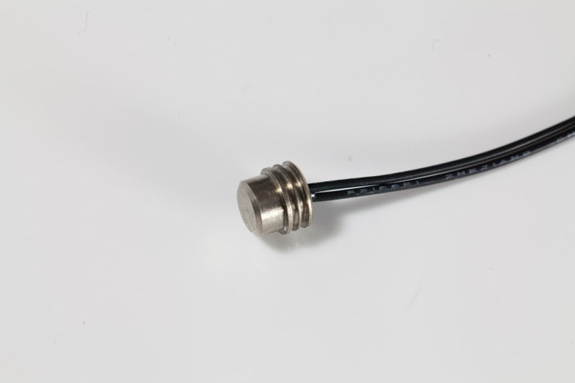 | 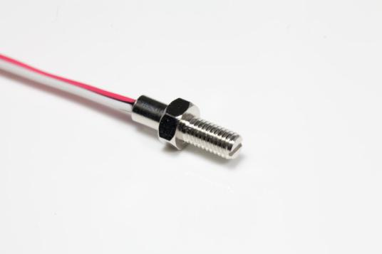
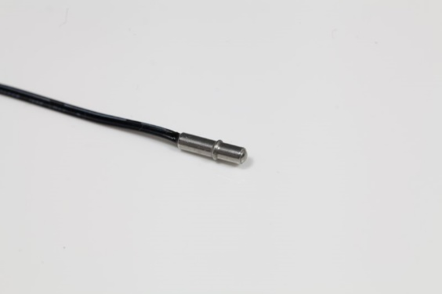 | 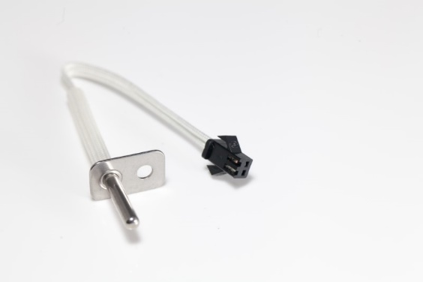
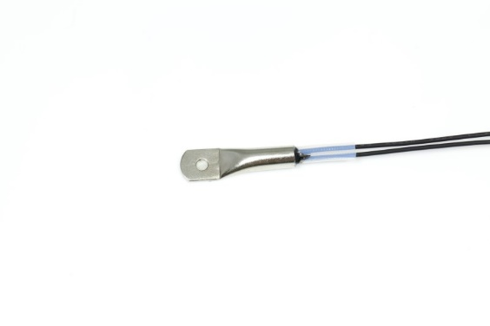 | 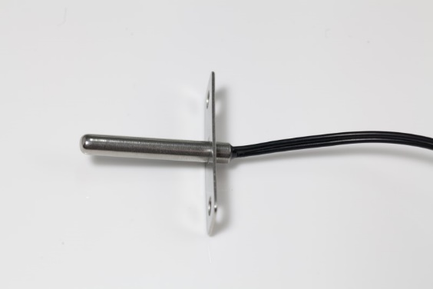
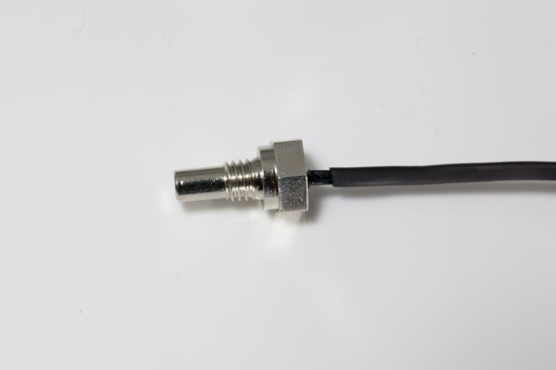 | 